setwd("C:/Users/nwelpulw/Desktop/Udemy/Projects/Corruption and Human developement")  
library(ggplot2)  
library(data.table)

## Warning: package 'data.table' was built under R version 3.4.2

df <- fread('Economist_Assignment_Data.csv',drop=1) # drop=1 to skip 1st column

check head of df

head(df)

## Country HDI.Rank HDI CPI Region  
## 1: Afghanistan 172 0.398 1.5 Asia Pacific  
## 2: Albania 70 0.739 3.1 East EU Cemt Asia  
## 3: Algeria 96 0.698 2.9 MENA  
## 4: Angola 148 0.486 2.0 SSA  
## 5: Argentina 45 0.797 3.0 Americas  
## 6: Armenia 86 0.716 2.6 East EU Cemt Asia

create a scatter plot.

pl <- ggplot(df,aes(x=CPI,y=HDI,color=Region)) + geom_point()  
pl

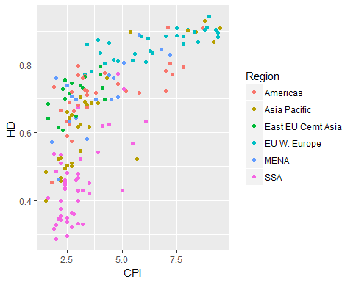

Change the points to be larger empty circles.

pl <- ggplot(df,aes(x=CPI,y=HDI,color=Region)) + geom_point(size=4,shape=1)  
pl

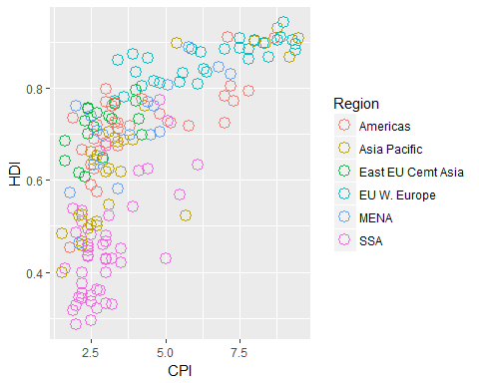

Add a trend line.

pl2<-pl + geom_smooth(aes(group=1),method ='lm',formula = y~log(x),se=FALSE,color='red')  
pl2

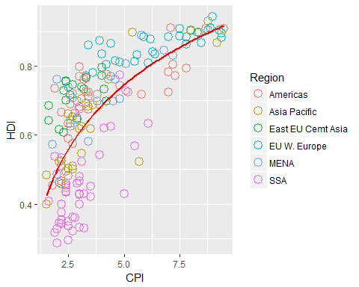

Add text to the points.

pl2<-pl2 + geom_text(aes(label=Country))

selecting the subset of countries we want to label!

pointsToLabel <- c("Russia", "Venezuela", "Iraq", "Myanmar", "Sudan",  
 "Afghanistan", "Congo", "Greece", "Argentina", "Brazil",  
 "India", "Italy", "China", "South Africa", "Spane",  
 "Botswana", "Cape Verde", "Bhutan", "Rwanda", "France",  
 "United States", "Germany", "Britain", "Barbados", "Norway", "Japan",  
 "New Zealand", "Singapore")  
  
pl3 <- pl2 + geom_text(aes(label = Country), color = "gray20",   
 data = subset(df, Country %in% pointsToLabel),check_overlap = TRUE) +theme_bw()   
  
pl3

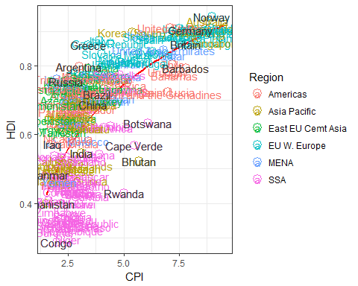

Adjusting x axis and y axis.

pl3 <- pl3 + scale_x_continuous(name = "Corruption Perceptions Index, 2011 (10=least corrupt)",  
 limits = c(.9, 10.5),breaks=1:10) +scale_y_continuous(name = "Human Development Index, 2011 (1=Best)",  
 limits = c(0.2, 1.0))+ ggtitle("Corruption and Human development")  
pl3

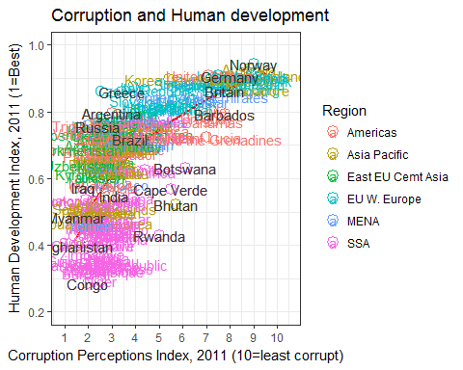

Adding Theme.

#install.packages('ggthemes')  
library(ggthemes)

## Warning: package 'ggthemes' was built under R version 3.4.2

pl3 + theme_economist_white()

